**Classroom Activity​: Do as directed**

* **Write a function that changes the background color of a <div> element to a random color when it is clicked​**
* **Write a function that displays an alert saying "Page Loaded!" when the page is fully loaded. ​**
* **Write a function that changes the border color of an input field to blue when it receives focus.​**
* **Write a function that validates a form to ensure the input field is not empty before submitting**

**​**

**Code:**

|  |
| --- |
| <!DOCTYPE html>  <html lang="en">  <head>  <meta charset="UTF-8">  <meta name="viewport" content="width=device-width, initial-scale=1.0">  <title>Class Activity</title>  <style>  #colorDiv {  width: 200px;  height: 200px;  background-color: lightgrey;  margin: 20px;  }  input {  display: block;  margin: 10px 0;  padding: 5px;  }  </style>  </head>  <body>  <div id="colorDiv">Click me to change my color</div>  <input type="text" id="textInput" placeholder="Focus on me to change border color">  <form id="myForm">  <input type="text" id="formInput" placeholder="Enter something">  <button type="submit">Submit</button>  </form>    <script>  // Function to change the background color of a <div> element to a random color when it is clicked  function changeBackgroundColor() {  const colorDiv = document.getElementById('colorDiv');  colorDiv.addEventListener('click', function() {  const randomColor = '#' + Math.floor(Math.random() * 16777215).toString(16);  colorDiv.style.backgroundColor = randomColor;  });  }    // Function to display an alert saying "Page Loaded!" when the page is fully loaded  function showAlertOnPageLoad() {  window.addEventListener('load', function() {  alert('Page Loaded!');  });  }    // Function to change the border color of an input field to blue when it receives focus  function changeBorderColorOnFocus() {  const textInput = document.getElementById('textInput');  textInput.addEventListener('focus', function() {  textInput.style.borderColor = 'blue';  });  }    // Function to validate a form to ensure the input field is not empty before submitting  function validateForm() {  const form = document.getElementById('myForm');  form.addEventListener('submit', function(event) {  const formInput = document.getElementById('formInput');  if (formInput.value.trim() === '') {  alert('Input field cannot be empty');  event.preventDefault(); // Prevent form from submitting  }  });  }    // Initialize functions  changeBackgroundColor();  showAlertOnPageLoad();  changeBorderColorOnFocus();  validateForm();  </script>  </body>  </html> |

**​**

**Output-**

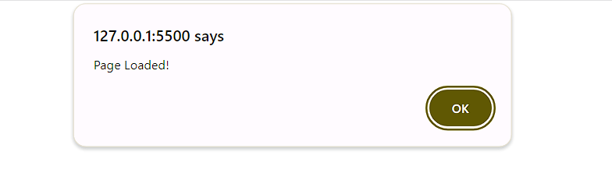

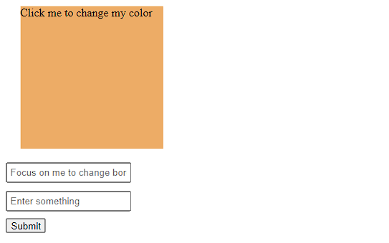

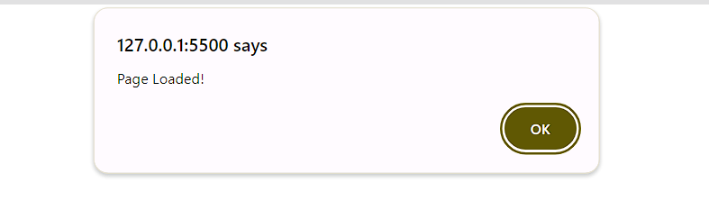

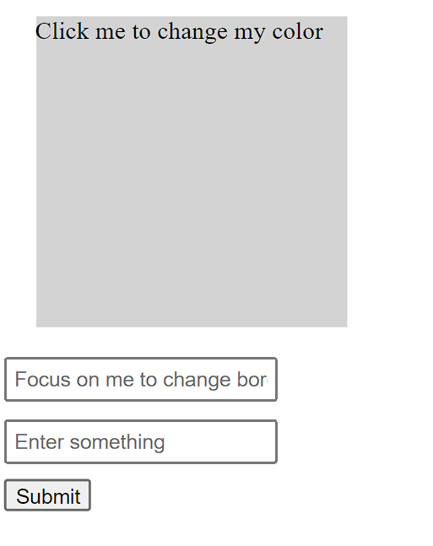

**Execution-Steps:**

* Create a JavaScript file with any name
* Write the code
* Run the code in the terminal using F5 or right click and go to inspect and you can get the output in the console as well.